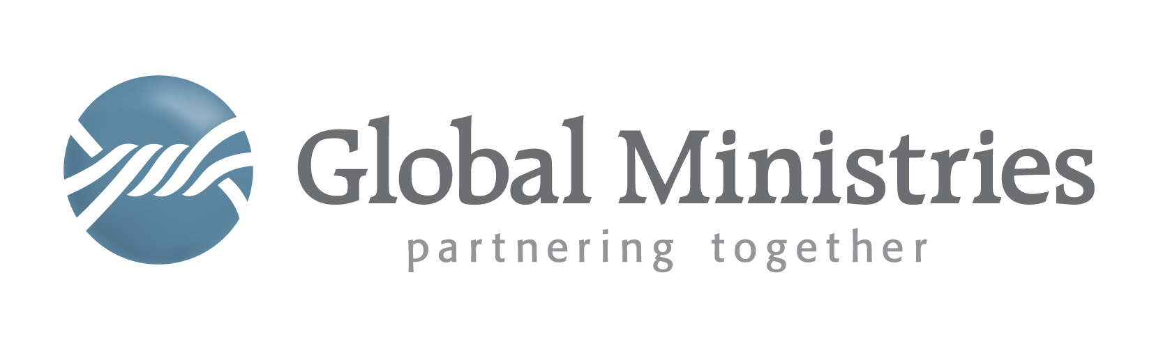
August 25, 2015

Dear Friends,

Global Ministries is the international arm of the United Brethren in Christ in Canada and the United States. We partner with the United Brethren Hospital in Mattru Jong, Sierra Leone and have the opportunity to assist them in obtaining a grant from USAID to install a solar electricity system with sufficient capacity to supply the hospital and enough surplus electricity for them to sell to their community.
Currently, the 75-bed hospital has no electric service other than what can be supplied by a diesel generator. Fuel costs are very high and so electricity is only produced when surgery is being performed. Being able to supply electricity to the hospital complex will allow them to be much more effective in providing care for patients, operating their lab and making use of computers, and conducting a variety of diagnostic procedures.
This particular grant is being directed at small organizations that function at a “grassroots” level. It comes as a result of the attention received during the Ebola crisis that sickened 13,492 people and resulted in the death of another 3,952 in Sierra Leone alone. Subject to the availability of funds, USAID may allocate up to a total of $10 million for approximately 10-20 discrete partnerships that advance their health, education and development objectives. It is also anticipated that up to a maximum of $2 million of additional funding from Power Africa may be available for one or more partnership(s) specifically focused on increasing electricity access in underserved areas in Liberia, Guinea and/or Sierra Leone. While there is no set range for co-investment, USAID may invest between $250,000 - $2,000,000 in individual partnerships, dependent on the impact and reach of the proposal.
In order for our grant proposal to succeed, USAID requires that we gain support from the private sector (including but not limited to African and multinational corporations, financial institutions, chambers of commerce, industry associations, foundations, entrepreneurs, investors and other private sector organizations). Local churches are also able to provide support.
Should you desire to participate, we require you provide us with a letter of intent. This letter would acknowledge you intend to response with financial support. The grant proposal does not require you to provide a specific amount, although you may do so at this time. Please note that the window of opportunity is narrow and we must have the proposal submitted by September 15, 2015.
If you, your organization, church or company is willing to support this project, please send us a letter expressing your intent to provide funding no later than Sept 7th. Please specify that you intend to support of the “Mattru Jong United Brethren in Christ Hospital” grant proposal for the solar electrification of its facilities.
Send your letter to us at the Global Ministries office:
302 Lake Street
Huntington IN 46804

Feel free to contact me if you have any questions.

Partners together,
Rev. Jeffrey C. Bleijerveld – Executive Director

